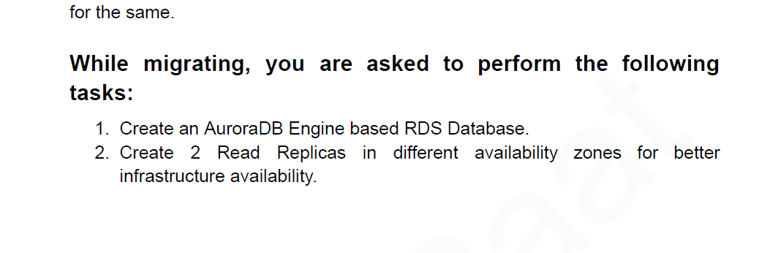

Soln 🡪

Search rds🡪 create database 🡪 select aurora mysql.

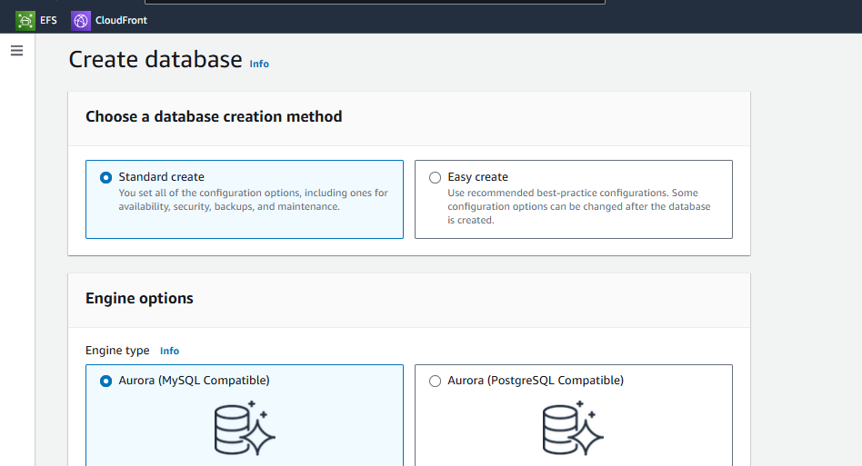

Select template.

Set password.

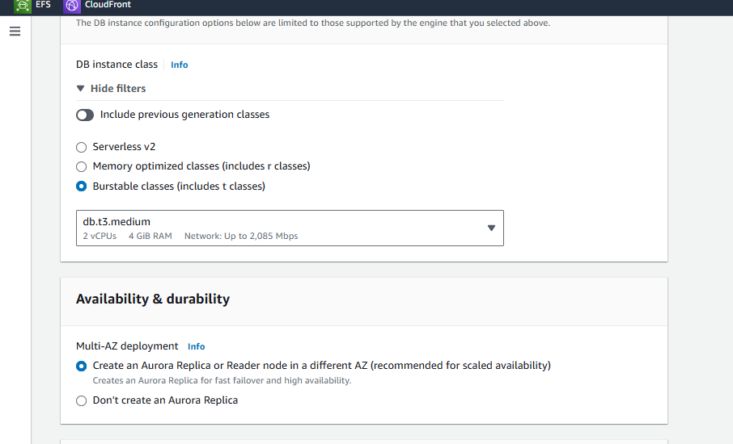

Select availability an durability

We have select first option to create reader node in different az.

Select vpc and subnet groups.

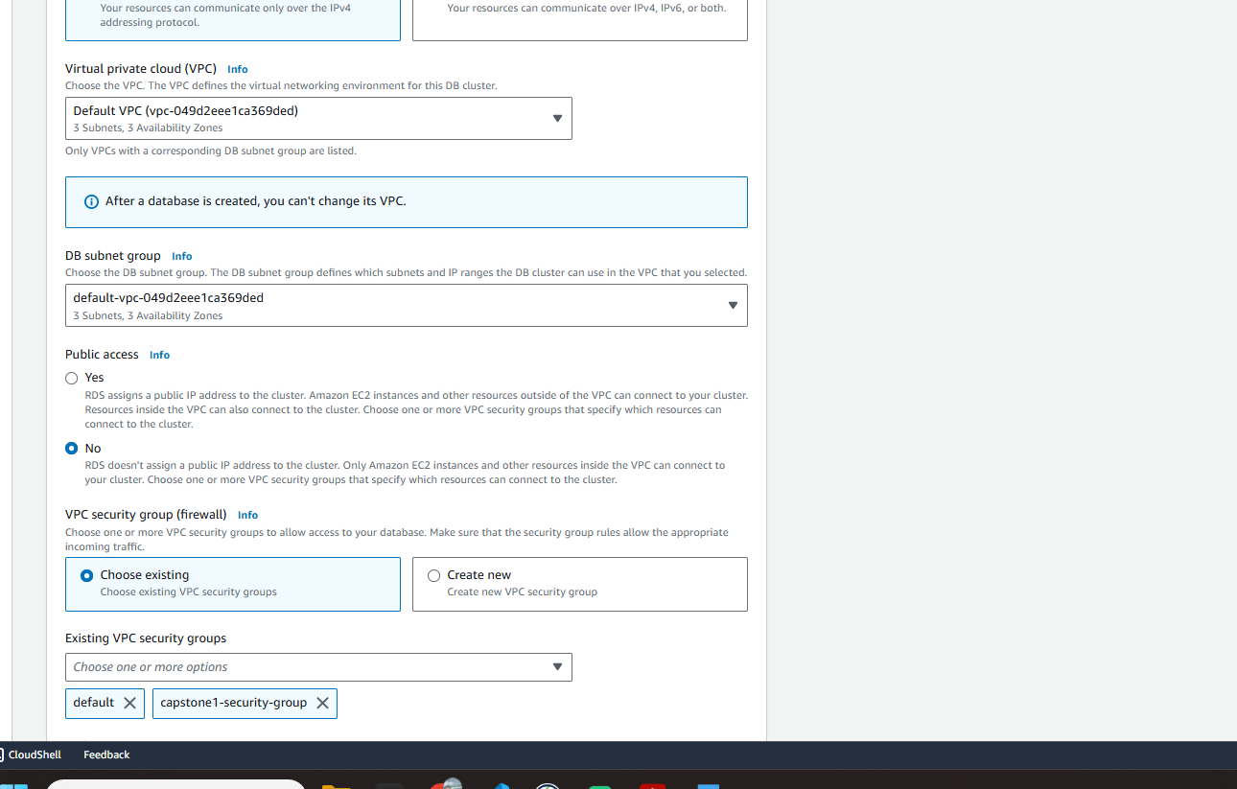

We have gone with default.

In security group we have choose our existing one in which we have allowed inbound calls for aurora/mysql.

Give database a name.

And create it.

We can see our maria db instance is getting created with reader node in different AZ.

Now after creation we can see one writer and one reader node.

Now to add one reader node select our db cluster 🡪 action 🡪add reader

While creating it select the different zone from writer.

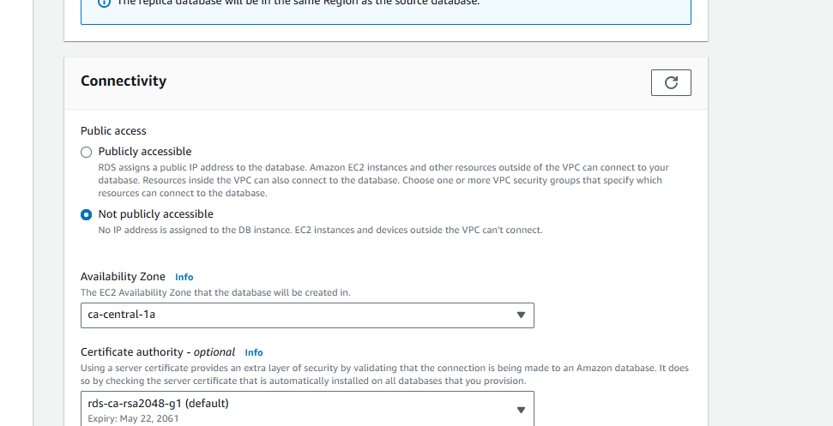

Make other things default and create it.

Now we can see our 2 different reader nodes in different AZ.

